- Retrieving the doc content from the Google doc and Querying Own Data (text file) with no OpenAI Integration

Initially the text file will be empty:
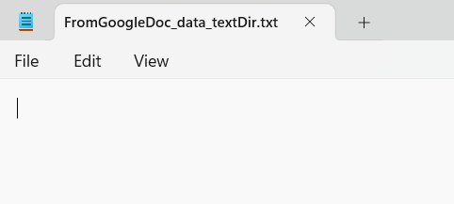

Google Doc content:
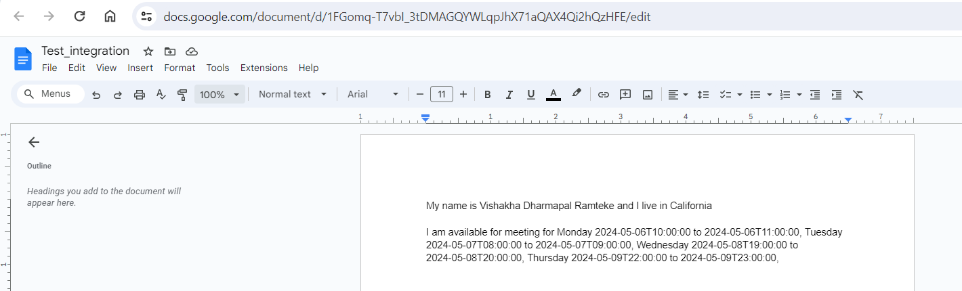

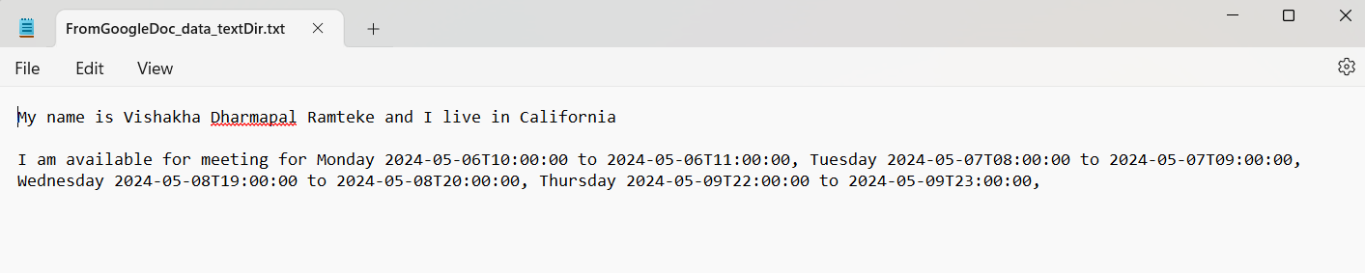
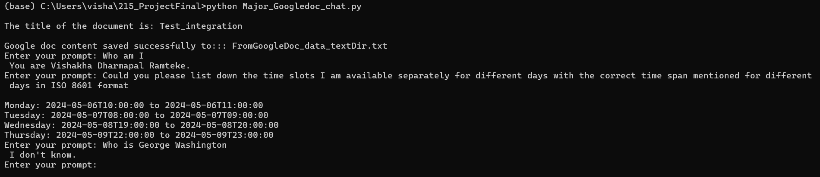
- Retrieving the doc content from the Google doc and Querying Own Data (text file) with OpenAI Integration

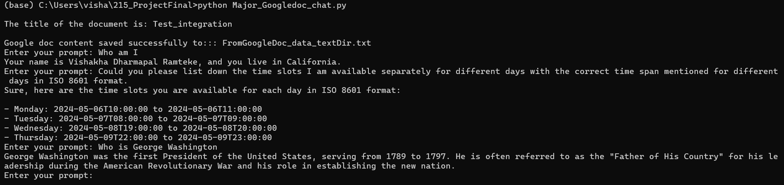

- Retrieving the doc content from the Google doc and Querying Own Data(folder) with no OpenAI Integration

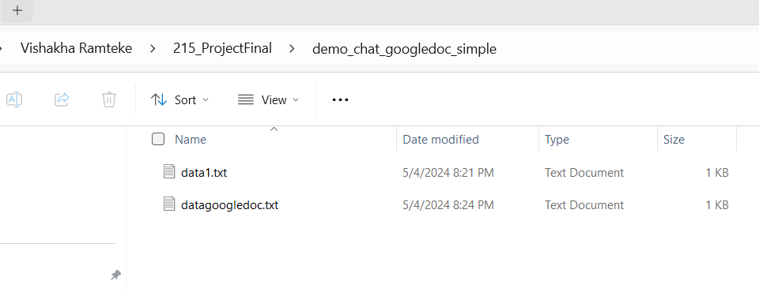

Initially the below text file will be empty:
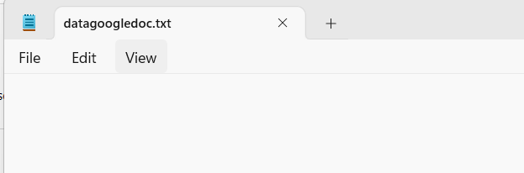
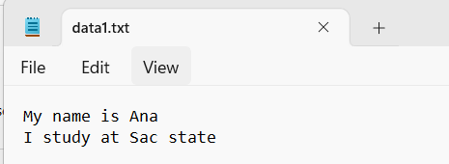
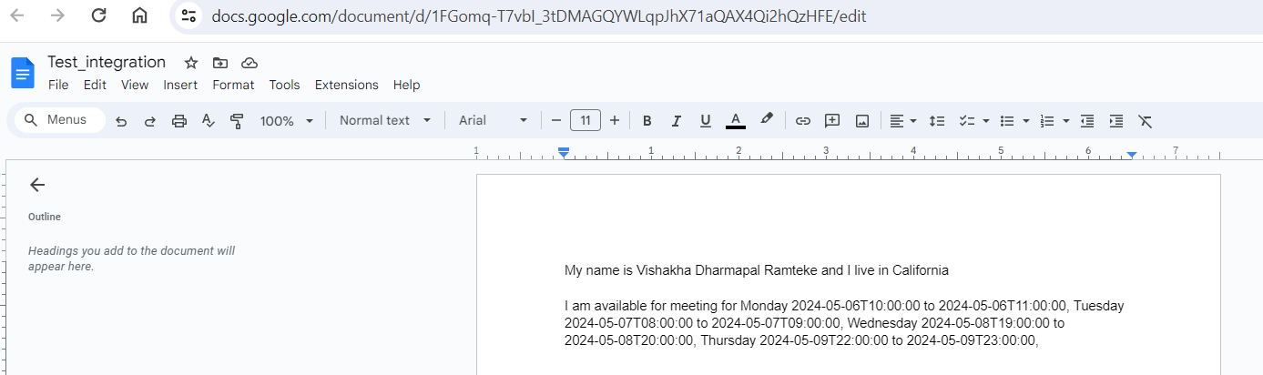

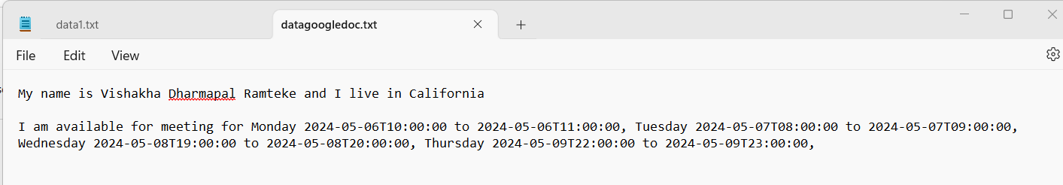

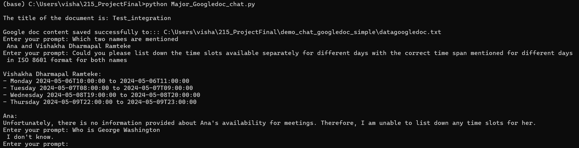

d) Retrieving the doc content from the Google doc and Querying Own Data(folder) with OpenAI Integration

